Word search project report

The first step: import the book and the booklet

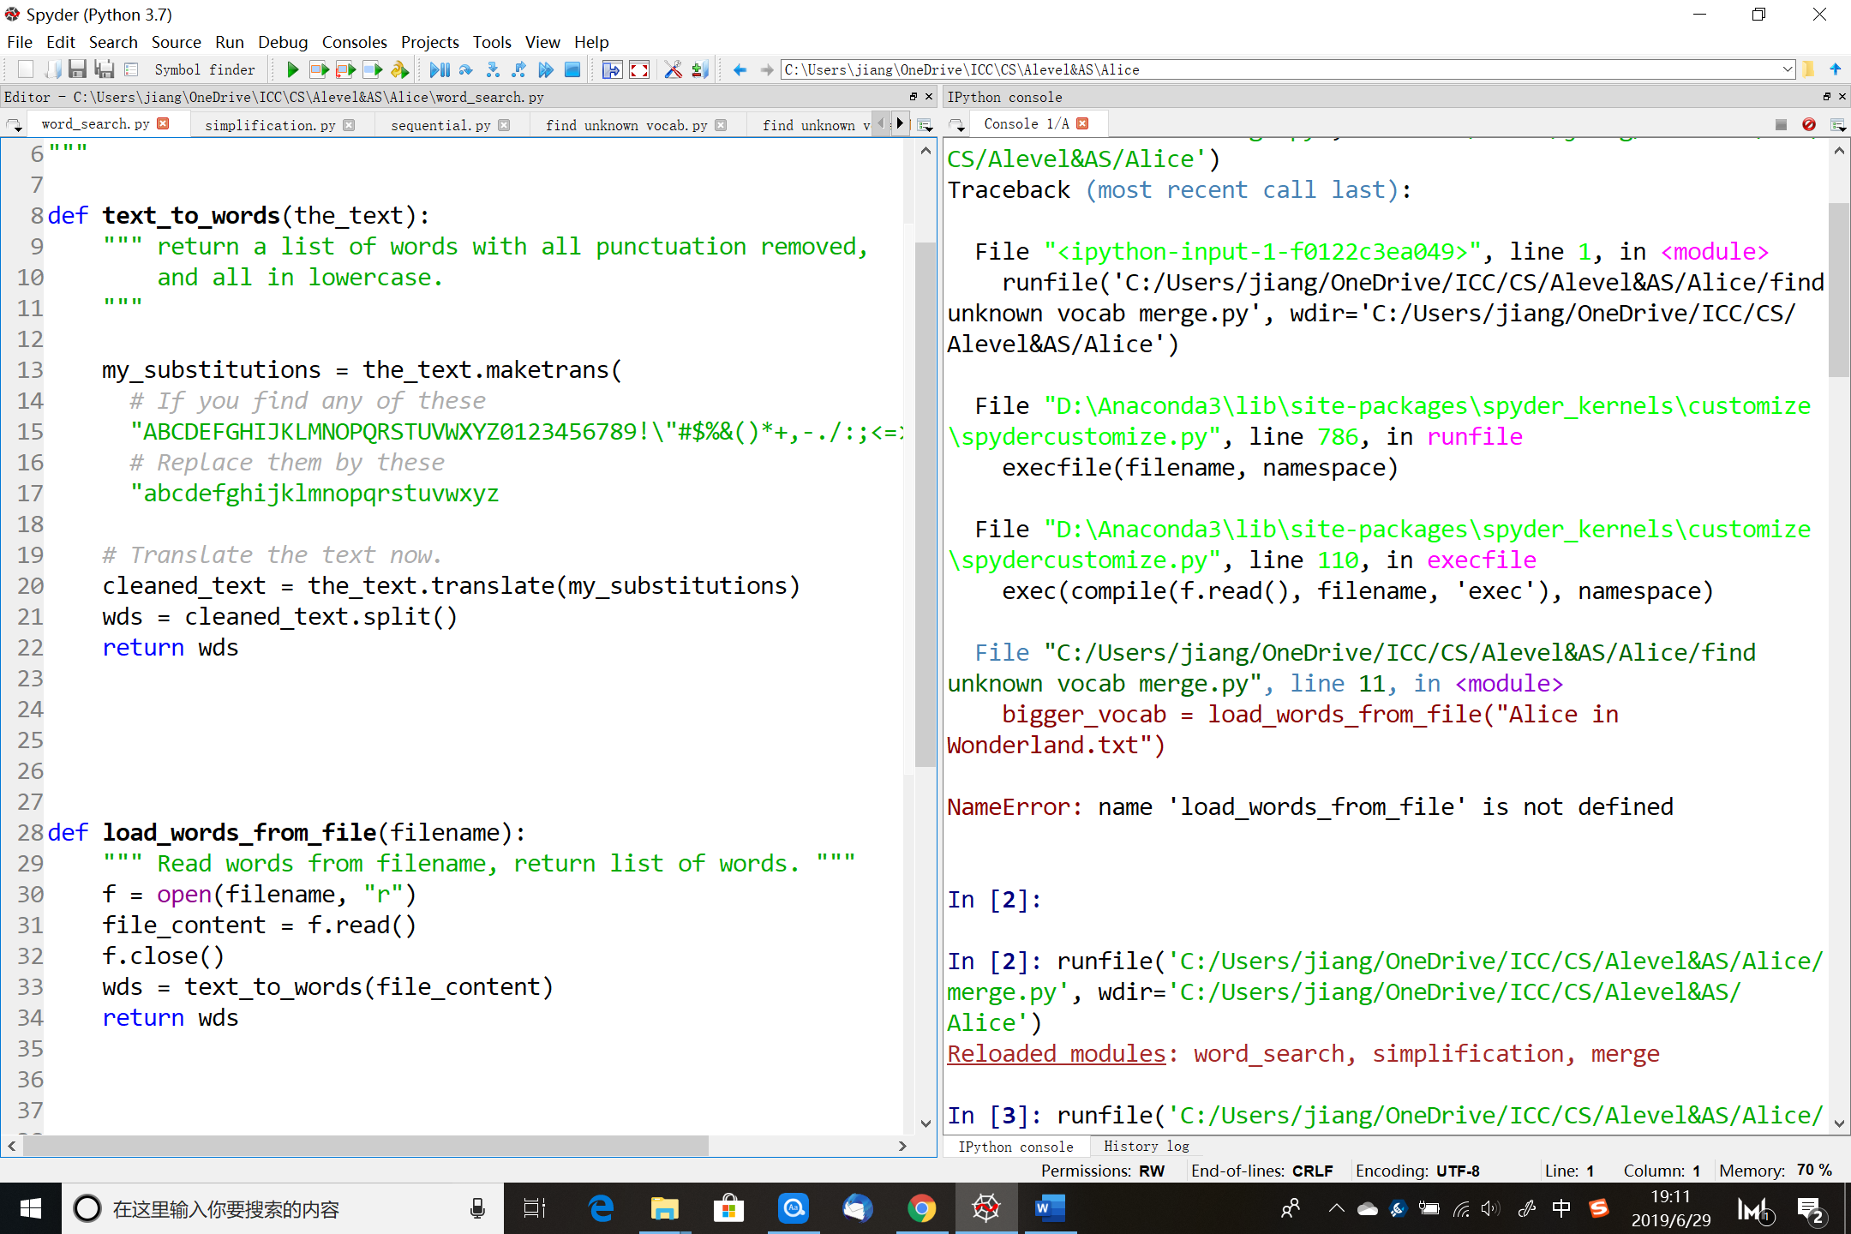

The first function is used to substitute all upper case letters, numbers and notations into spaces. The second function is used to import the book.

The second step: simplify the book

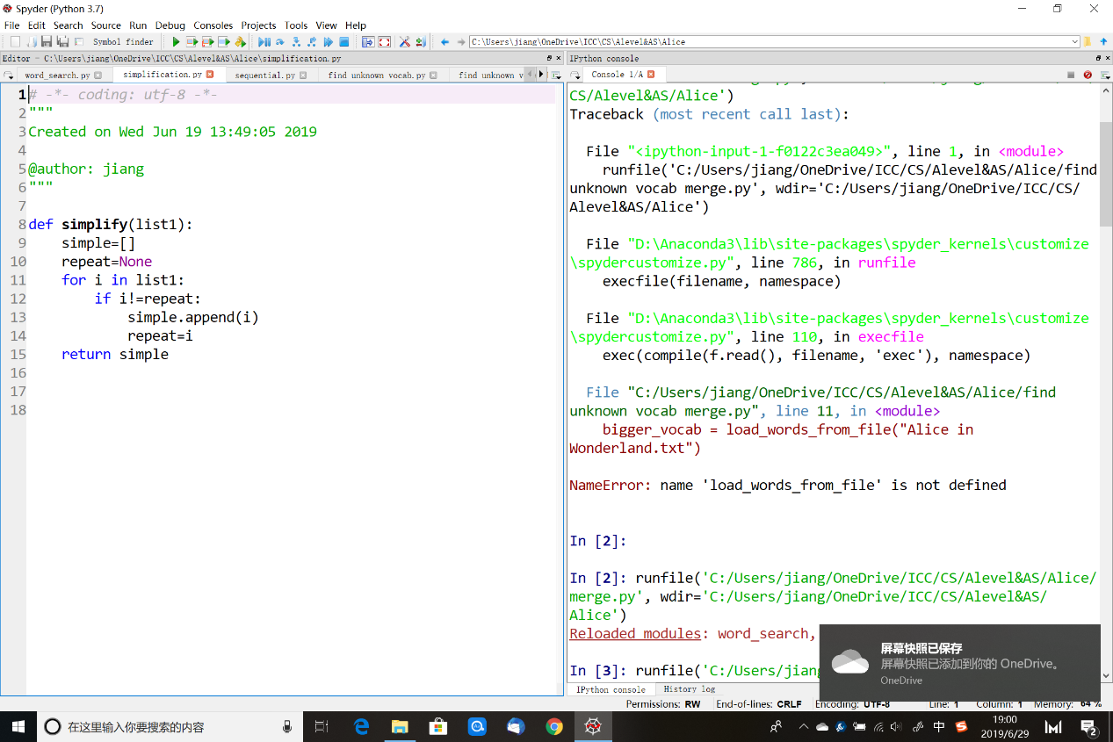

This function is used to remove repeated words in the book.

The third step: try the sequential search algorithm

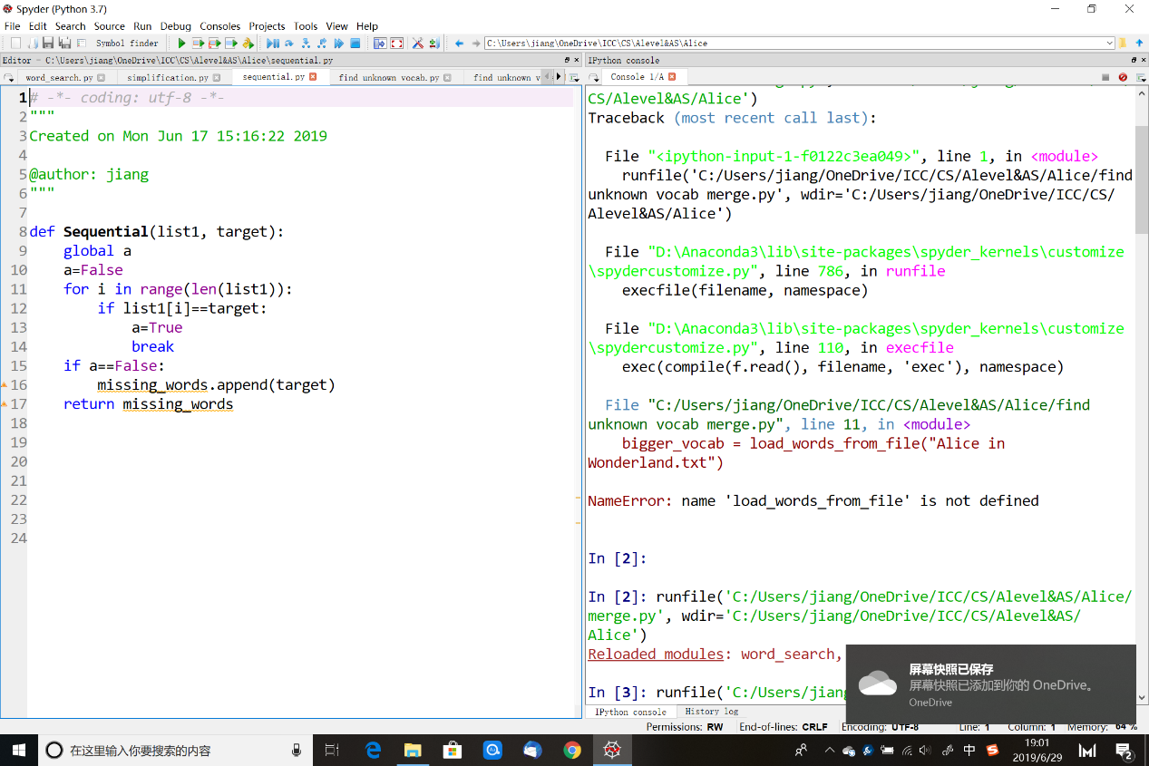

This is the function of sequential search.

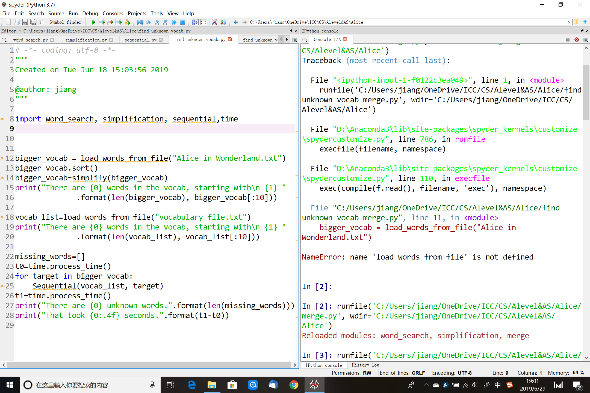

This the completed algorithm for sequential search. The first step is to import all the functions needed. After that, I imported the book and the booklet using the word_search function. Then, use the sequential function to find unknown words, at the same time record the time used.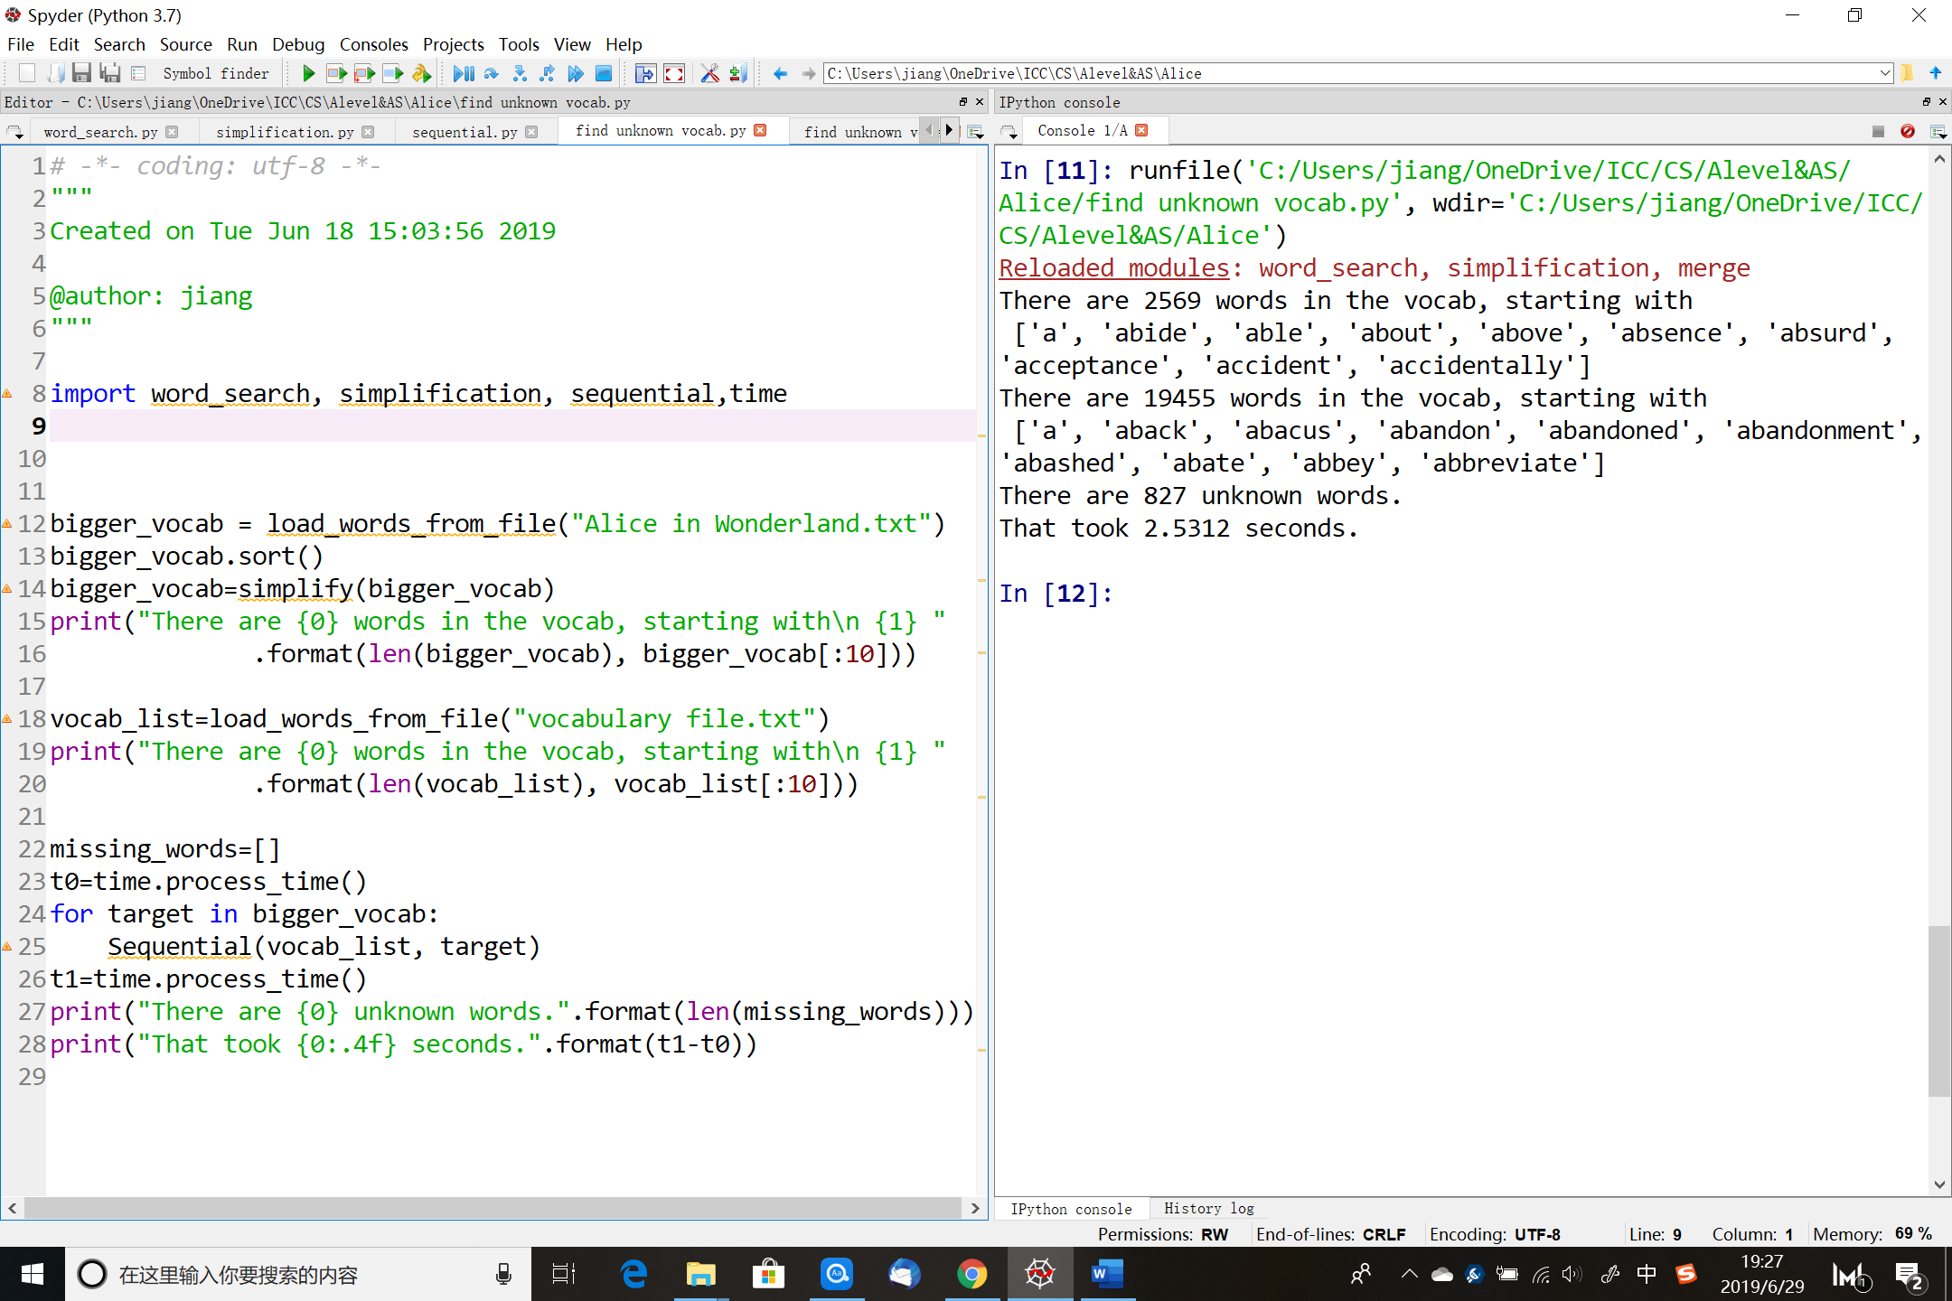

The sequential method used 2.5s to find 827 unknown words in 2569 words from the book.

The fourth step: try the binary search algorithm

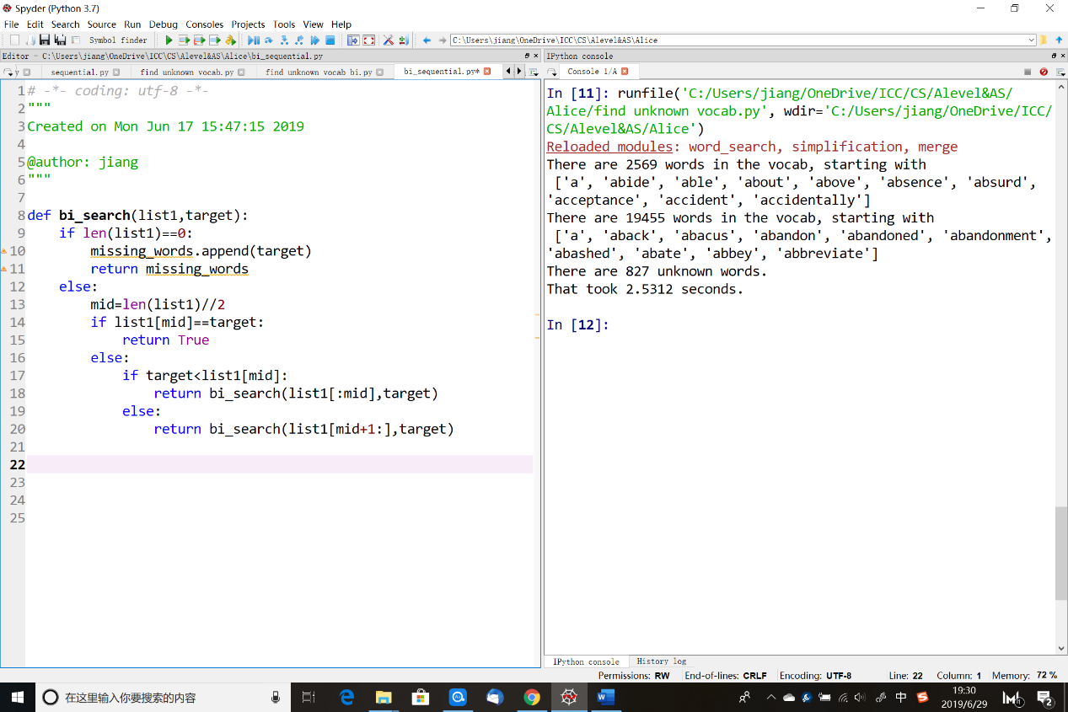

The function of binary search

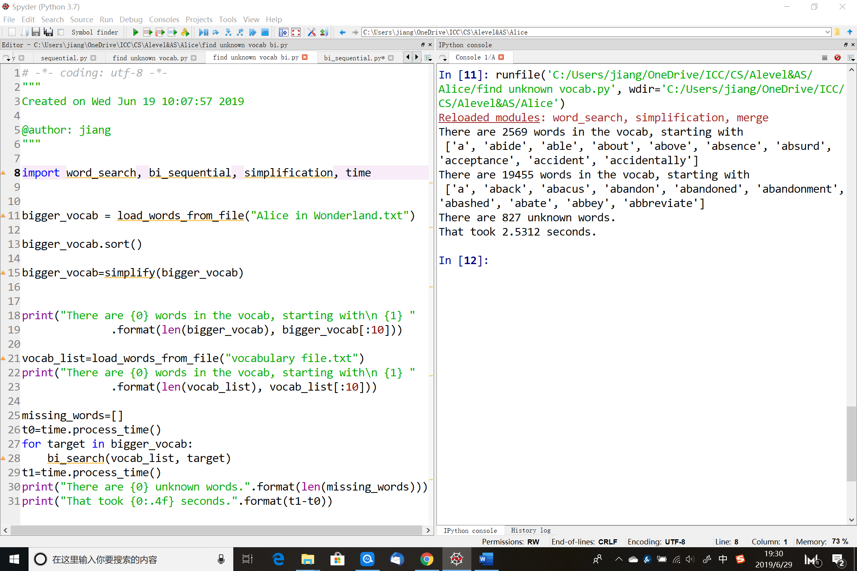

Do the similar steps as in the sequential algorithm.

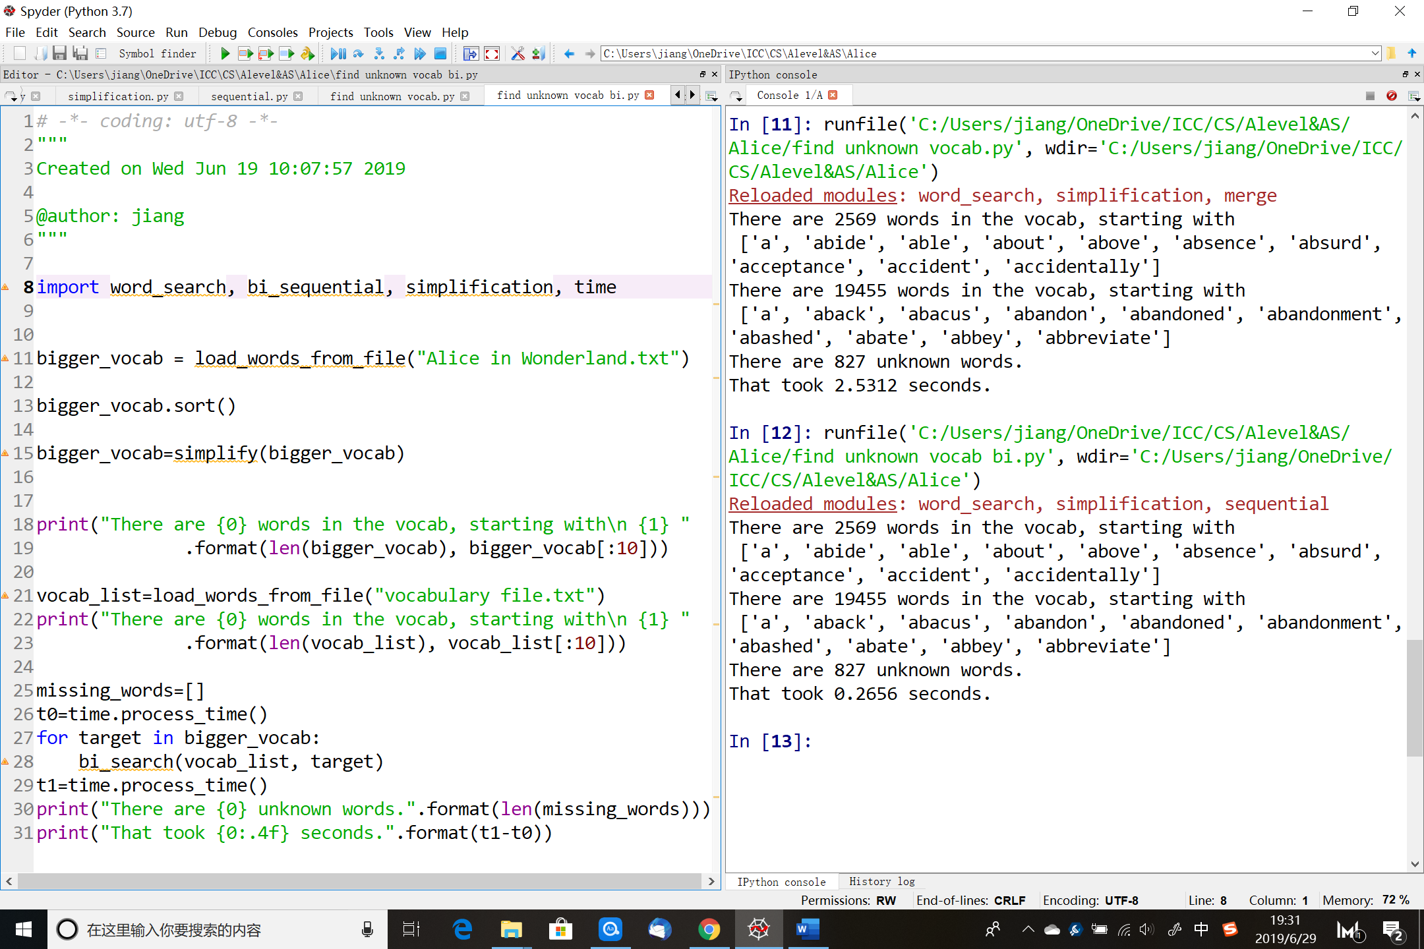

The binary method only use 0.27s to do the same thing, much faster than the sequential one.

The fifth step: try the merging search algorithm

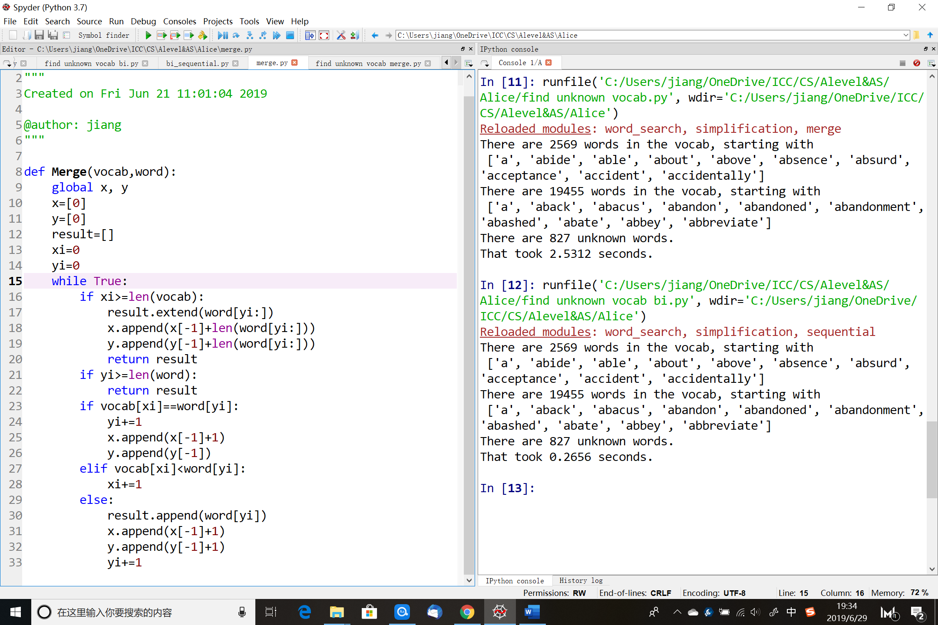

The function of merging search

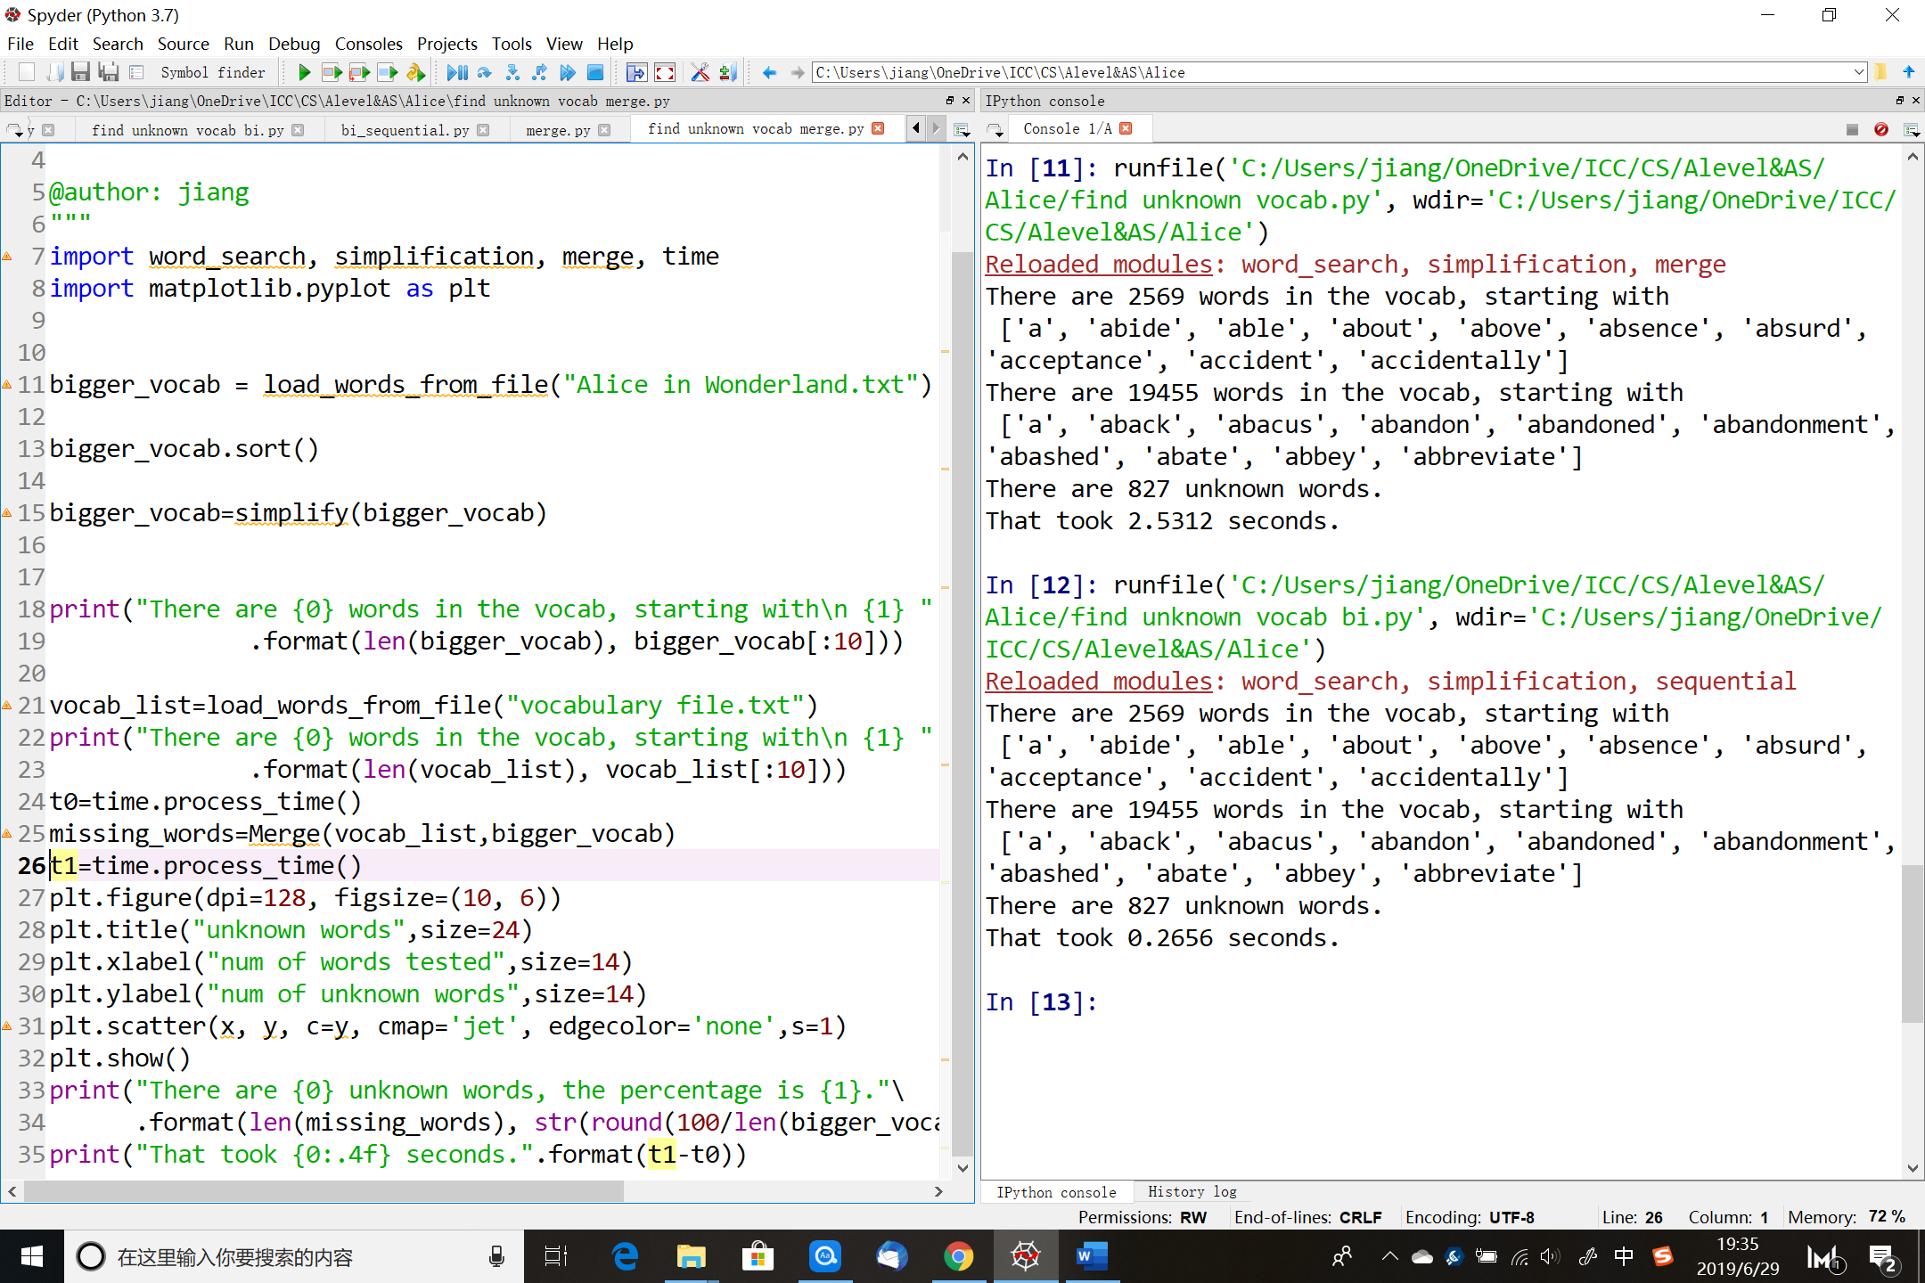

Do about the same thing as before, but this time I calculated the percentage of unknown words and plotted a graph of the searching process.

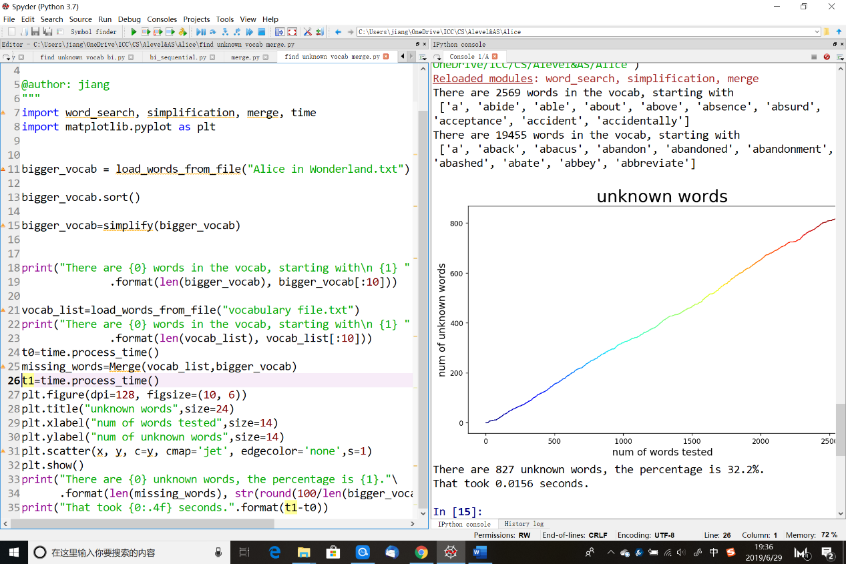

This time, it only takes 0.0156s to finish the searching.